APTS WebApp User Manual
Module Functionalities, Logical Flow, Validations, and Actual Screens
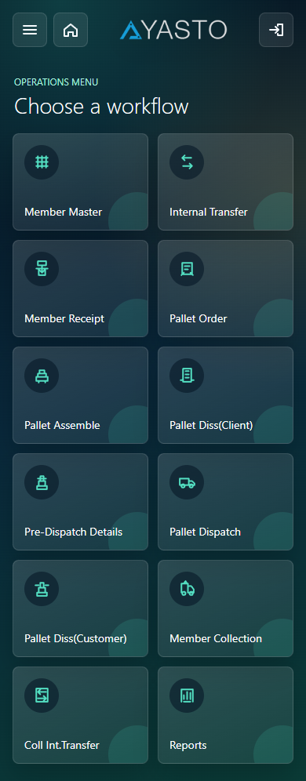
Actual screen captured from the APTS WebApp dev site.
Application | Ayasto Pallet Tracking System WebApp
Environment | Dev site: https://aptswebappdev.ayasto.com/
Screen Capture | 10-Aug-2026 12:00 PM
Location Used | AM/NS Pune
Scope | Login, Menu, master, transfer, receipt, pallet, collection, reports, and settings modules.

Module Index
Module | Screen Included
Login Module | Yes - actual dev-site screenshot
Menu Module | Yes - actual dev-site screenshot
Member Master Module | Yes - actual dev-site screenshot
Member Tagging Module | Yes - actual dev-site screenshot
Internal Transfer Module | Yes - actual dev-site screenshot
Member Receipt Module | Yes - actual dev-site screenshot
Pallet Order Module | Yes - actual dev-site screenshot
Pallet Order Details Screen | Yes - actual dev-site screenshot
Pallet Assemble Module | Yes - actual dev-site screenshot
Pallet Dismantle Client Module | Yes - actual dev-site screenshot
Pallet Pre-Dispatch Module | Yes - actual dev-site screenshot
Pallet Dispatch Module | Yes - actual dev-site screenshot
Pallet Dismantle Customer Module | Yes - actual dev-site screenshot
Member Collection Module | Yes - actual dev-site screenshot
Collection Internal Transfer Module | Yes - actual dev-site screenshot
Reports Module | Yes - actual dev-site screenshot
Settings Module | Yes - actual dev-site screenshot
Current Stock Report | Yes - actual dev-site screenshot
Discrepancy Report | Yes - actual dev-site screenshot
High Age Report | Yes - actual dev-site screenshot
Member Transaction Report | Yes - actual dev-site screenshot
Query Report | Yes - actual dev-site screenshot

Overall Application Flow
- User logs in with valid credentials and selects an authorized location.
- The menu is loaded based on user menu access.
- The user performs operational transactions such as member creation, tagging, transfer, receipt, pallet order, pallet assembly, dispatch, dismantle, or collection.
- Each transaction validates scanned member/pallet data before saving.
- Successful transactions update master/detail tables, counts, locations, and transaction history as applicable.
- Reports provide stock, discrepancy, aging, transaction, and query visibility.
Important control: Across all modules, a failed transaction should not partially update related master/detail/count records. Transactional database handling is required wherever multiple dependent tables are updated together.

Login Module
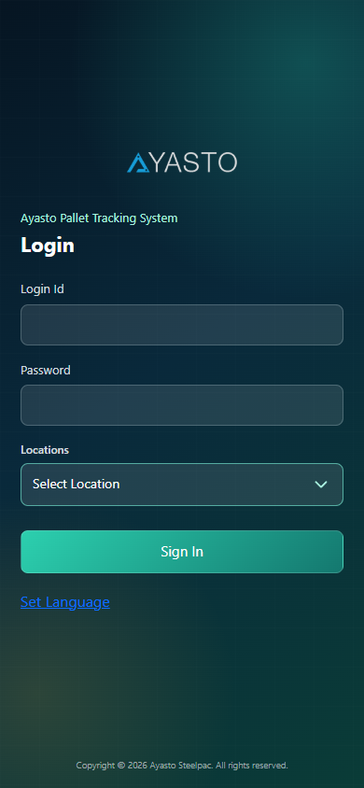
Actual screen: Login page on the dev site.
Purpose: Authenticates the user and starts an application session for the selected operating location.
Primary users: All web application users.
Logical flow: The user opens the login page, enters credentials, selects a location, and the application validates user access before loading the menu.
- User enters Login Id and Password.
- User selects the operating location.
- System validates credentials against active web users.
- System validates whether the user is mapped to the selected location.
- On success, session values such as user, role, location, and menu access are created.
- User is redirected to the Menu screen.
Main functionalities:
- Login Id and password authentication.
- Location-based access selection.
- Language settings from the login page.
- Session creation for role, menu, customer, and location context.
Validations and controls:
- Location is mandatory.
- Invalid Login Id or Password is rejected.
- Users without access to the selected location are blocked.
- Inactive users are not allowed to proceed.

Menu Module
Actual screen: Main menu after successful login.
Purpose: Provides module navigation according to the logged-in user's assigned web menu access.
Primary users: All authenticated users.
Logical flow: After login, the system displays allowed module tiles. The user selects a tile to open the required operation.
- Application reads menu access from the authenticated session.
- Menu tiles are displayed for available modules.
- User selects a module tile.
- Application opens the selected module with the current location context.
Main functionalities:
- Role-based module visibility.
- Quick navigation to operational modules and reports.
- Logout and settings access.
Validations and controls:
- Unauthenticated users are redirected to Login.
- Only mapped menu items are available to the user.
- Session timeout requires fresh login.

Member Master Module
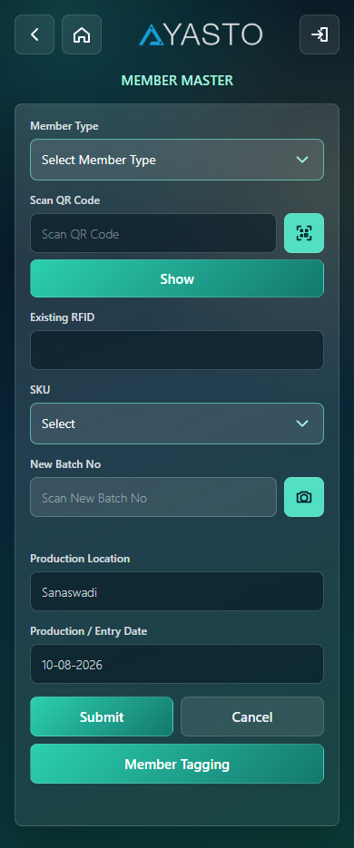
Actual screen: Member Master creation form.
Purpose: Creates member records with batch, size, type, and QR/RFID details.
Primary users: Factory, warehouse, and master-data users.
Logical flow: The user enters member details, validates batch and QR information, and saves the member master record.
- Select or enter member attributes such as type, size, batch, and quantity.
- Scan or enter member QR/RFID values.
- System validates duplicate or existing QR details.
- User submits the form.
- System creates the member record and makes it available for tagging and transactions.
Main functionalities:
- Member master entry.
- SKU/size lookup.
- Batch number validation.
- Existing QR lookup.
Validations and controls:
- Required member fields must be entered.
- Duplicate batch or QR values are blocked according to business rules.
- Invalid or unmatched SKU details are not accepted.
- Save is blocked until mandatory scan/member details are complete.

Member Tagging Module
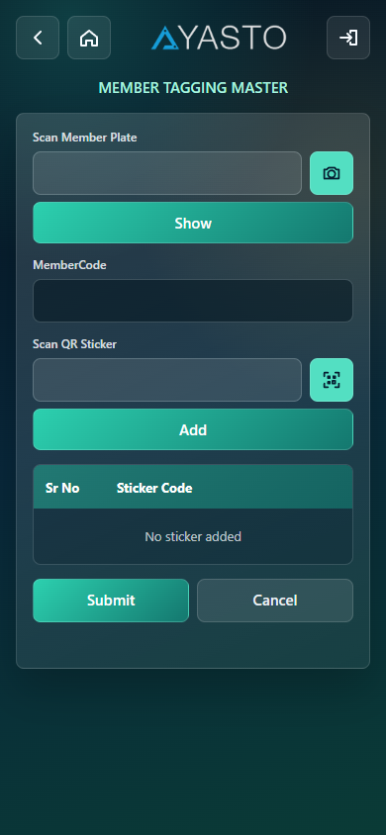
Actual screen: Member Tagging form.
Purpose: Maps physical RFID/sticker information to a member record.
Primary users: Tagging and operations users.
Logical flow: The user scans or enters member and sticker details, validates them, and saves the tag mapping.
- Scan or enter the member plate/QR.
- System fetches member details.
- Scan or enter sticker/RFID details.
- System validates sticker availability.
- User saves the tagging transaction.
Main functionalities:
- Member lookup by plate/QR.
- Sticker/RFID validation.
- Tagging save transaction.
Validations and controls:
- Member must exist before tagging.
- Sticker/RFID must be valid and unused.
- Duplicate tagging is blocked.
- Mandatory scan fields cannot be blank.

Internal Transfer Module
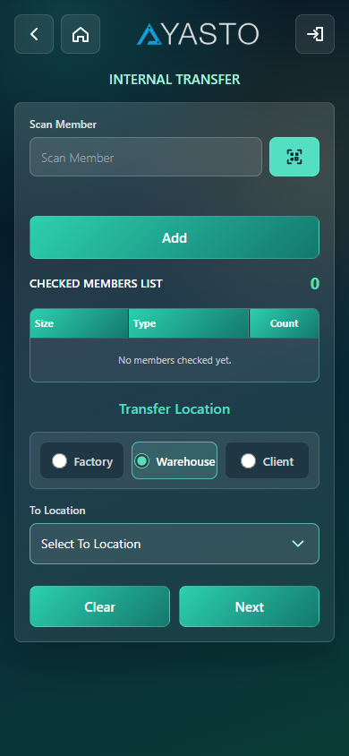
Actual screen: Internal Transfer setup.
Purpose: Transfers members from one internal location to another using dispatch scanning.
Primary users: Warehouse and internal logistics users.
Logical flow: The user prepares a dispatch setup, scans members, validates location eligibility, and submits the transfer.
- Select transfer setup details such as destination and truck information.
- Open member dispatch scanning.
- Scan member QR/RFID.
- System validates current location and dispatch eligibility.
- Submit scanned members to complete internal transfer.
Main functionalities:
- Transfer setup entry.
- Member dispatch scanning.
- Truck/driver/transporter details where required.
- Transfer save and challan generation support.
Validations and controls:
- Destination and required dispatch setup fields are mandatory.
- Member must be available at the current logged-in location.
- Duplicate scanned members are blocked.
- Invalid location members require bypass or are rejected as per rule.

Member Receipt Module
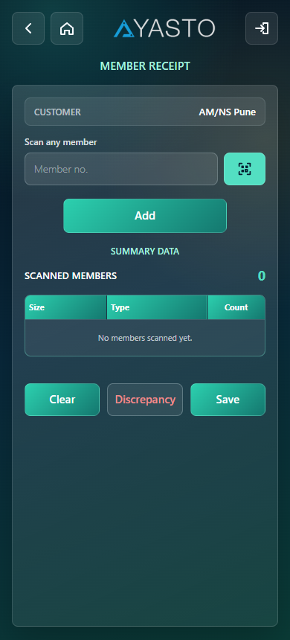
Actual screen: Member Receipt scan page.
Purpose: Receives internally transferred members at the destination location.
Primary users: Receiving location users.
Logical flow: The user scans transferred members and saves receipt after validation.
- Open the receipt scan page.
- Scan received member QR/RFID.
- System validates pending receipt eligibility.
- Review scanned members.
- Submit receipt to update current member location.
Main functionalities:
- Member receipt scanning.
- Pending transfer validation.
- Receipt save transaction.
Validations and controls:
- Member must be part of a valid pending transfer.
- Duplicate receipt scans are blocked.
- Submit is blocked when no members are scanned.
- Receipt location must match logged-in receiving context.

Pallet Order Module
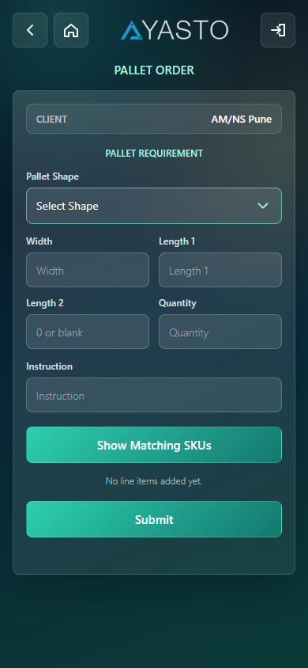
Actual screen: Pallet Order header entry.
Purpose: Creates customer pallet orders with required dimensions and order quantities.
Primary users: Planning, operations, and pallet order users.
Logical flow: The user enters order header details, moves to detail entry, adds SKU/order quantities, and submits the order.
- Select customer/order context.
- Enter order header details.
- Open order detail page.
- Enter width, lengths, sizes, and order quantities.
- Submit the pallet order.
Main functionalities:
- Customer order entry.
- Order detail capture.
- Matching SKU lookup based on shape/width/length.
- Order count tracking.
Validations and controls:
- Customer and required order fields are mandatory.
- Order quantity must be valid.
- SKU/dimension matching must be valid.
- Incomplete details cannot be submitted.

Pallet Order Details Screen
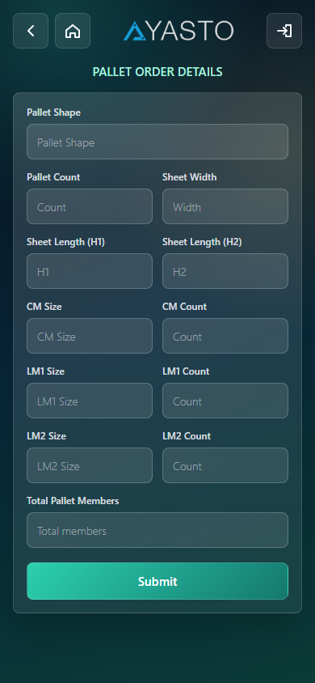
Actual screen: Pallet Order detail entry.
Purpose: Captures line-level pallet order details before order submission.
Primary users: Planning and operations users.
Logical flow: The user adds detail rows for pallet requirements and submits them under the pallet order.
- Open details from Pallet Order.
- Enter sheet dimensions and quantities.
- Validate matching SKU details.
- Add the detail line.
- Submit the order details.
Main functionalities:
- Detail-level dimension entry.
- SKU matching.
- Quantity entry.
Validations and controls:
- Width and length values must be valid.
- Quantity must be greater than zero.
- Duplicate or invalid detail combinations are blocked where configured.
- Submit requires at least one valid detail line.

Pallet Assemble Module

Actual screen: Pallet Assemble order/member scan screen.
Purpose: Assembles members into a pallet against a pallet order detail.
Primary users: Pallet assembly users.
Logical flow: The user selects pallet order details, scans member QR/RFID values, validates them, and submits the assembled pallet.
- Select customer and pallet order detail.
- Review order count, assemble count, and pending count.
- Scan member QR/RFID values.
- System validates member location and pallet eligibility.
- Submit the pallet assembly transaction.
- System creates pallet master/detail records and updates assemble count only when the transaction completes.
Main functionalities:
- Pallet order lookup.
- Member scan list.
- Pallet QR generation.
- Assemble count tracking.
Validations and controls:
- Pallet already created within the configured duplicate window is blocked.
- Member must be available at the current location.
- Duplicate member scans are blocked.
- Submit is blocked when required member count is not satisfied.
- Assemble count should be updated only after the pallet transaction is complete.
Notes: The module should keep pallet master/detail and order assemble count in a single transactional flow so partial failures do not show incorrect assemble counts.

Pallet Dismantle Client Module
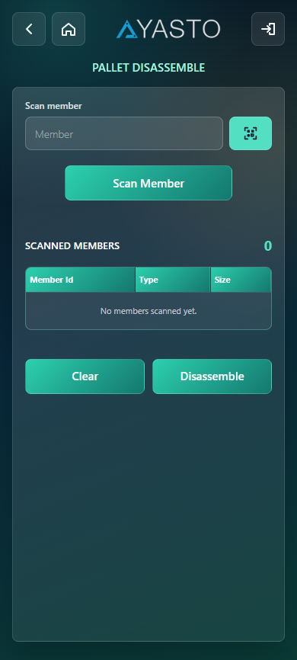
Actual screen: Pallet Dismantle Client scan screen.
Purpose: Dismantles a pallet at the client/internal side and releases members from the pallet.
Primary users: Client-side operations users.
Logical flow: The user scans pallet/member information, validates the pallet status, and saves dismantle details.
- Open the client dismantle page.
- Scan member or pallet QR/RFID.
- System validates that the item can be dismantled.
- Review scanned members.
- Submit dismantle transaction.
Main functionalities:
- Pallet/member scan validation.
- Scanned member list.
- Dismantle save transaction.
Validations and controls:
- Scanned member must belong to a valid pallet.
- Duplicate scans are blocked.
- Submit requires scanned members.
- Only eligible pallet statuses can be dismantled.

Pallet Pre-Dispatch Module
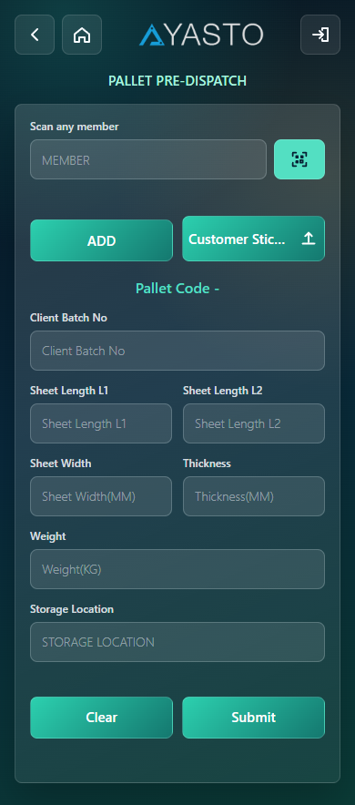
Actual screen: Pallet Pre-Dispatch scan screen.
Purpose: Pre-dispatches pallets or members against client batch details before final dispatch.
Primary users: Dispatch preparation users.
Logical flow: The user scans the pallet/member, checks existing pre-dispatch status, and saves pre-dispatch data.
- Open the pre-dispatch page.
- Scan member or pallet QR/RFID.
- System validates member details.
- Enter or verify client batch number.
- Save pre-dispatch transaction.
Main functionalities:
- Member/pallet validation.
- Existing pre-dispatch check.
- Client batch linkage.
- Pre-dispatch save.
Validations and controls:
- Scanned item must be eligible for pre-dispatch.
- Existing pre-dispatch records are checked to avoid duplication.
- Client batch number is required where applicable.
- Submit is blocked for invalid or duplicate scans.

Pallet Dispatch Module
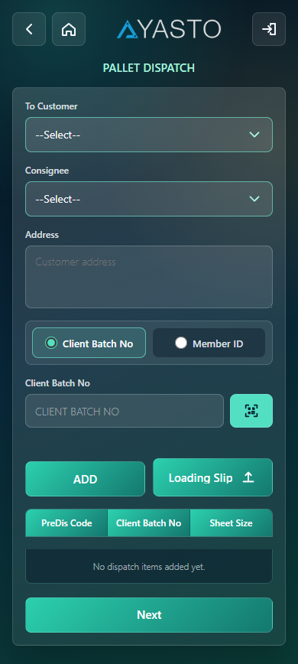
Actual screen: Pallet Dispatch setup screen.
Purpose: Dispatches pallets to the customer or ship-to location.
Primary users: Dispatch users.
Logical flow: The user enters dispatch setup details, scans pallets or batches, validates them, and saves final dispatch.
- Enter dispatch header and transportation details.
- Open dispatch detail scanning.
- Scan pallet or batch values.
- System validates dispatch eligibility.
- Submit dispatch.
- Challan/mail generation can be triggered after dispatch.
Main functionalities:
- Dispatch setup entry.
- Pallet/batch scan validation.
- Batch lookup.
- Dispatch save and challan support.
Validations and controls:
- Required dispatch and vehicle fields must be entered.
- Scanned pallet/batch must be pre-dispatched or otherwise eligible.
- Duplicate dispatch scans are blocked.
- Invalid scan type/value is rejected.

Pallet Dismantle Customer Module
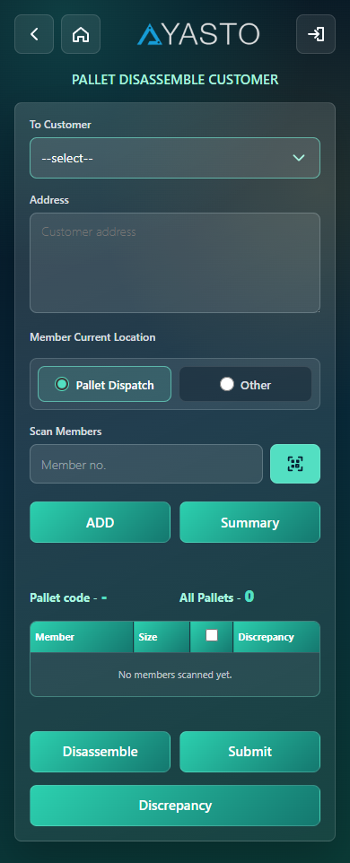
Actual screen: Pallet Dismantle Customer screen.
Purpose: Records pallet dismantling at customer side and stores customer dismantle details.
Primary users: Customer return/collection users.
Logical flow: The user scans customer-side members, stores temporary dismantle details, reviews them, and submits final dismantle.
- Open customer dismantle page.
- Scan member QR/RFID.
- System validates customer/location eligibility.
- Temporary dismantle details are saved.
- User reviews scanned details.
- Final submit records the customer dismantle transaction.
Main functionalities:
- Customer-side scan validation.
- Temporary scan detail storage.
- Final dismantle submission.
Validations and controls:
- Member must belong to the customer/location context.
- Duplicate temporary scans are blocked.
- Final submit requires valid temporary details.
- Invalid customer location members are rejected.

Member Collection Module
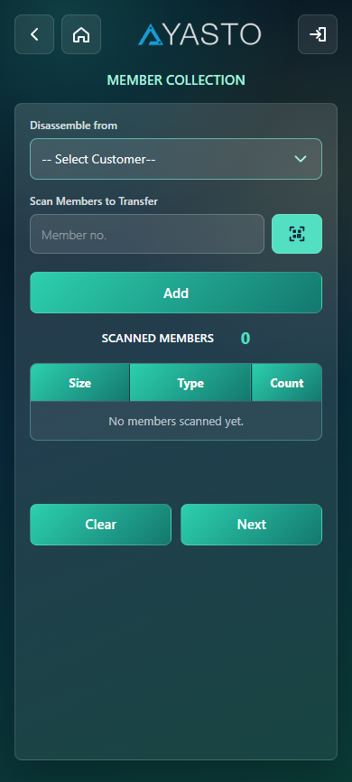
Actual screen: Member Collection setup screen.
Purpose: Collects loose members from customer or collection locations.
Primary users: Collection and reverse logistics users.
Logical flow: The user enters collection setup details, scans members, validates customer collection eligibility, and saves the collection.
- Select customer/collection context.
- Open collection detail scanning.
- Scan member QR/RFID.
- System validates whether the member can be collected.
- Review scanned members.
- Save member collection.
Main functionalities:
- Collection setup entry.
- Customer member validation.
- Scanned member list.
- Collection save and challan support.
Validations and controls:
- Customer/collection setup fields are mandatory.
- Scanned member must be available for collection.
- Duplicate scans are blocked.
- Submit requires at least one valid member.
- The save request must complete normally before reporting success.

Collection Internal Transfer Module
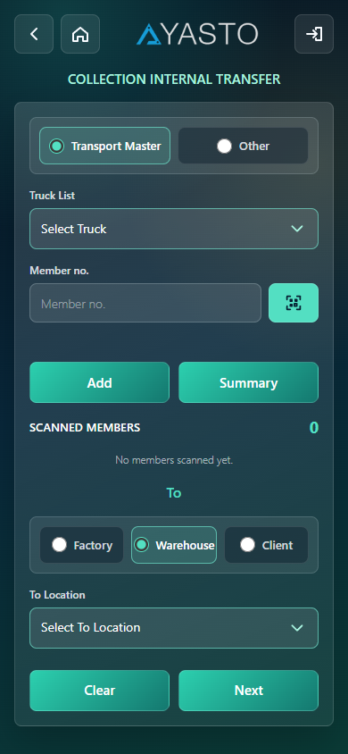
Actual screen: Collection Internal Transfer setup.
Purpose: Transfers collected members internally after collection.
Primary users: Collection and internal logistics users.
Logical flow: The user enters transfer setup details, scans collected members, validates them, and submits the transfer.
- Enter collection transfer setup details.
- Scan collected member QR/RFID.
- System validates member and truck/location context.
- Review scanned members.
- Submit collection internal transfer.
Main functionalities:
- Collected member transfer setup.
- Scan validation.
- Truck and transporter detail handling.
- Transfer save transaction.
Validations and controls:
- Required transfer setup fields are mandatory.
- Member must be eligible for collection transfer.
- Duplicate scans are blocked.
- Invalid truck/location context is rejected or requires bypass where configured.

Reports Module
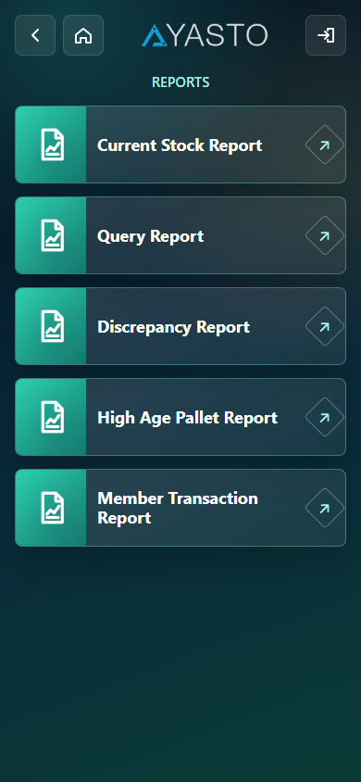
Actual screen: Reports menu.
Purpose: Provides access to operational and stock reports.
Primary users: Operations, planning, management, and audit users.
Logical flow: The user opens Reports and selects the required report type.
- Open Reports from the menu.
- Select a report tile.
- Enter filter criteria.
- Generate the report.
- Review displayed results.
Main functionalities:
- Current Stock report.
- Discrepancy report.
- High Age report.
- Member Transaction report.
- Query report.
Validations and controls:
- Report filters must be valid.
- Date ranges must be logical.
- Required filter fields are enforced per report.
- Empty results are handled without saving any transaction.

Settings Module

Actual screen: Settings page.
Purpose: Allows the user to change application language settings.
Primary users: All authenticated users.
Logical flow: The user opens settings, selects a language, and saves the preference.
- Open Settings from menu.
- Select preferred language.
- Save settings.
- Application stores the selected language in session/cookie context.
Main functionalities:
- Language selection.
- User preference persistence.
Validations and controls:
- Only supported language codes are accepted.
- Invalid language values default safely to English.

Report Screens

Current Stock Report
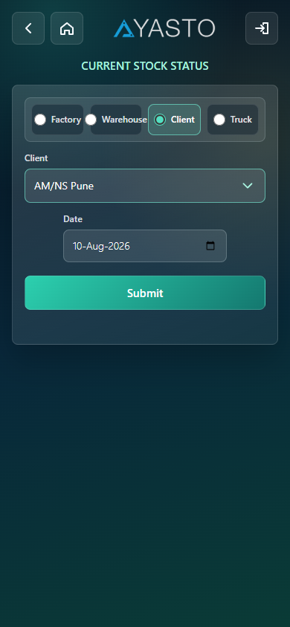
Actual screen: Current Stock Report.
Purpose | Shows stock by selected stock location and optional client filters.
Validation | Stock location is required; report filters must be valid.
Output | Displays filtered operational data for review and follow-up.

Discrepancy Report
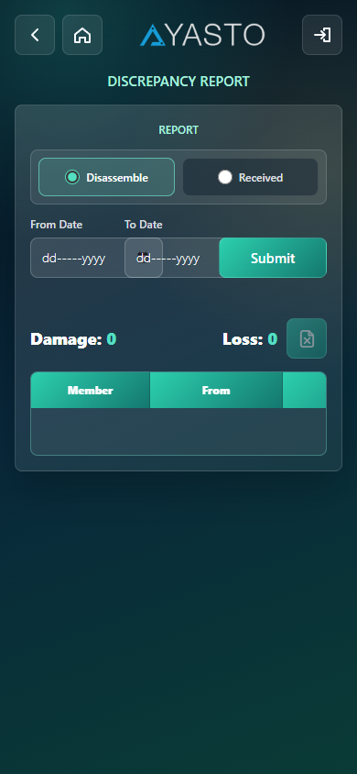
Actual screen: Discrepancy Report.
Purpose | Shows stock/transaction discrepancies for investigation.
Validation | Date and filter inputs must be valid before report generation.
Output | Displays filtered operational data for review and follow-up.

High Age Report
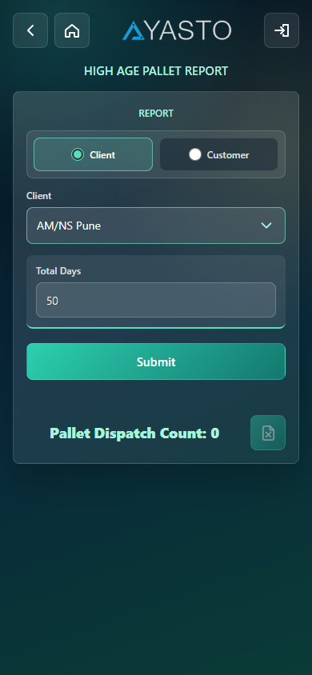
Actual screen: High Age Report.
Purpose | Shows aged members based on selected high-age type, location, and date filters.
Validation | High-age type and dependent location options are validated.
Output | Displays filtered operational data for review and follow-up.

Member Transaction Report
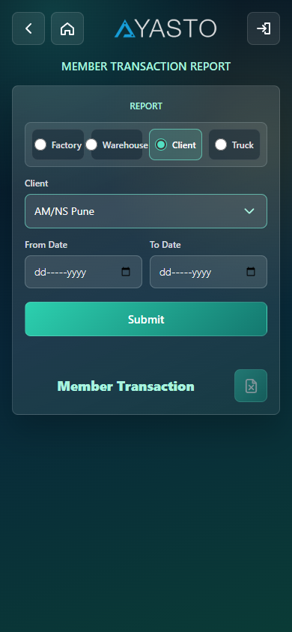
Actual screen: Member Transaction Report.
Purpose | Shows member movement/transaction history based on selected filters.
Validation | Member/date/filter values must be valid.
Output | Displays filtered operational data for review and follow-up.

Query Report
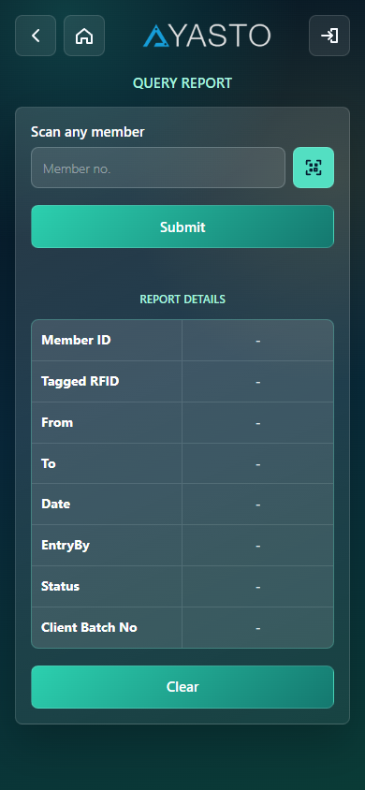
Actual screen: Query Report.
Purpose | Provides ad-hoc operational query output based on selected criteria.
Validation | Required query filters must be entered before generation.
Output | Displays filtered operational data for review and follow-up.

Challan and Mail Support
Challan and mail generation is a supporting backend function used after dispatch, member collection, pallet order, and dismantle transactions. It is generally triggered from transaction completion rather than maintained as a separate data-entry screen.
- Generates challan output for dispatch and collection flows.
- Uses transaction code references such as pallet dispatch, member dispatch, member collection, pallet dismantle, and pallet order.
- Should be triggered only after the parent transaction is saved successfully.
- Failures in challan generation should be logged and shown clearly without corrupting the saved transaction.

